TRAINING AND PLACEMENT CELL
ACADEMIC YEAR 2024-2025
Integra Company Puducherry, campus drive placement" on 26.11.2024
The Integra Company Puducherry conducted the On-campus Placement Drive on 26.11.2024 at Achariya Arts and Science College. The Final Year UG and PG students participated in the placement drive for the positions of Project Management Executive Trainee, Technical Editor Trainee, Copy Editor Trainee and Composer trainee with the annual CTC ranging from Rs. 2.25 to 2.70 Lakhs.
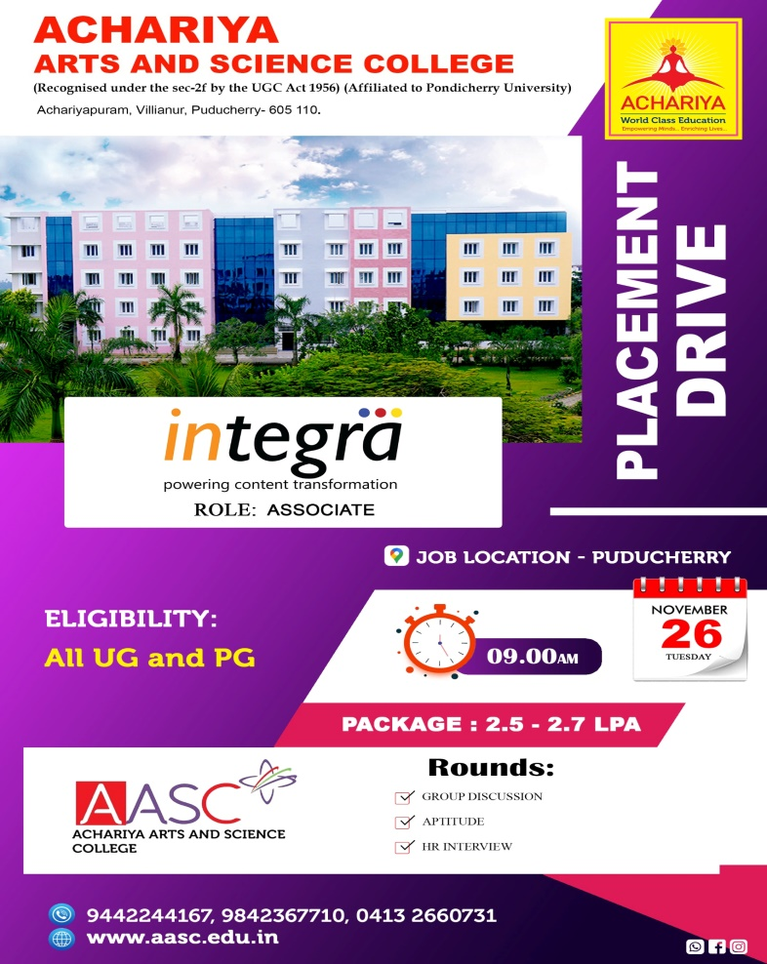
Mr. Dheepan and Mr. Arun, Senior HR Executives and three HR Executives presided over the session. The Campus Placement had two rounds starting with a Written test followed by a Face-to-face Interview. Overall, 141 students participated and 98 students were shortlisted for various positions.

